Lab Document 2

Program Design Arthur Coll

Problem 1

Problem: Verifying that people are the correct age when entering nightclub.  
Objective is to create program that asks age and allows access if they have the correct age.  
Design:

1. Insert “When Flag clicked” function to the start of the nightclub program
2. Ask the age of the person who is trying to enter the club using the say function
3. Check that age is greater than or equal to 18, if it is below this, refuse entry to club via the say function and restart program for next person using forever tag.
4. Restart program using forever tag.

Test cases: Entering the ages of 18 “a” and 16

Tested: Program partially works, when age entered is below 18 is entered they are denied entry however when random non numerical characters are entered the program allows entry.  
Answers will need to be validated to prevent this.

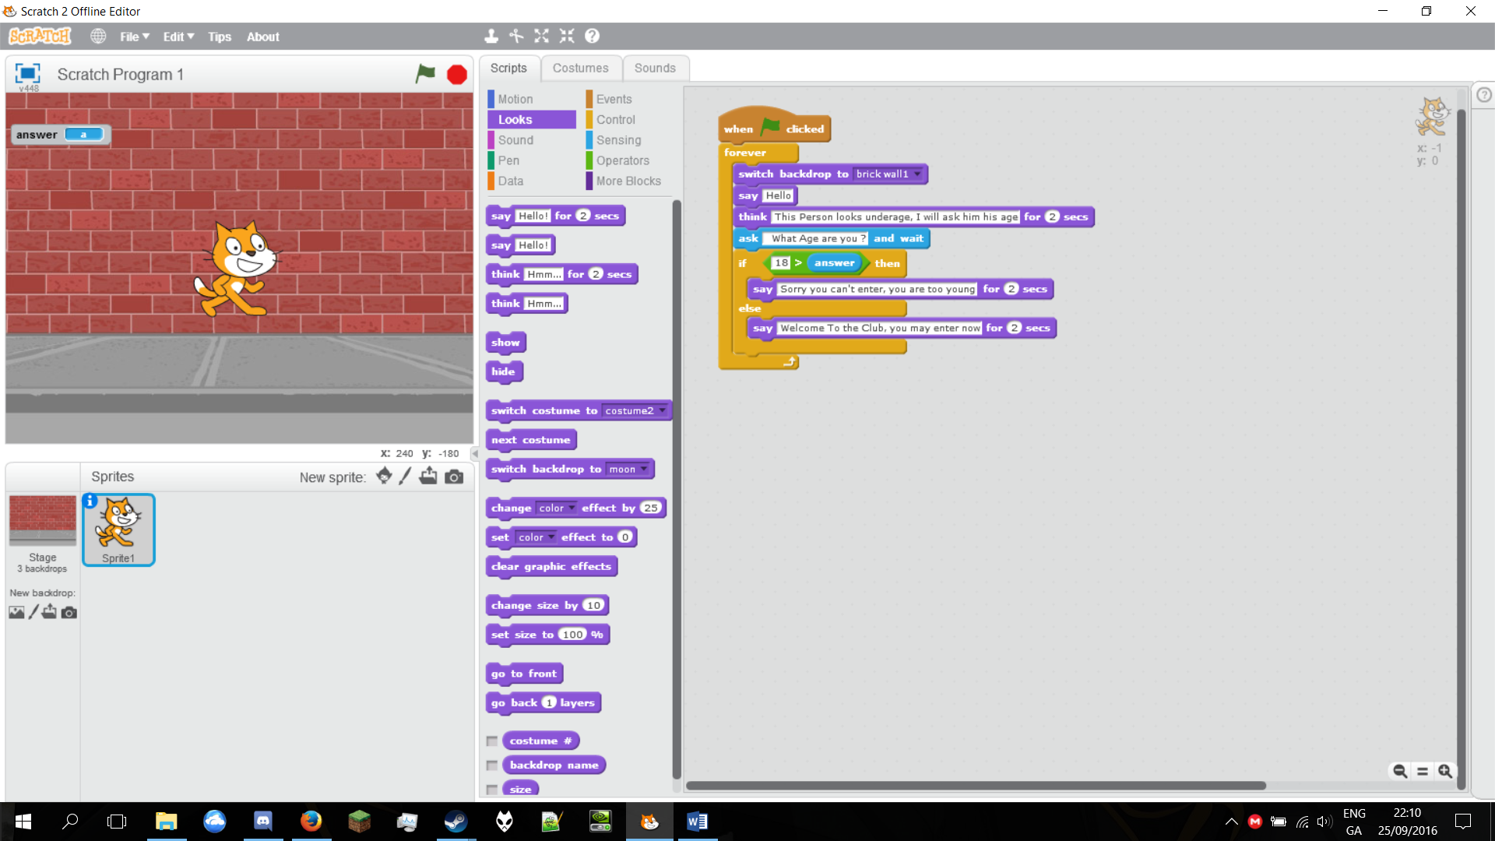

Problem 2  
Problem: Finding the product of three numbers

Objective To create a program that will ask 3 users for input numbers and get their product

1. Ask first number they would like to multiply
2. Store in variable named Num1
3. Ask the second number they would like to get product of
4. Store in variable named Num2
5. Ask the third number they would like to multiply
6. Store in variable named Num3
7. Put first two variables (Num1&Num2) in a multiplication function
8. Then put this variable inside another multiplication variable.
9. Announce the answer by putting both the combined multiplication functions in a say function.

Test cases: Enter the numbers 3, 7 and 10

Tested: Answers are correctly added, program works.

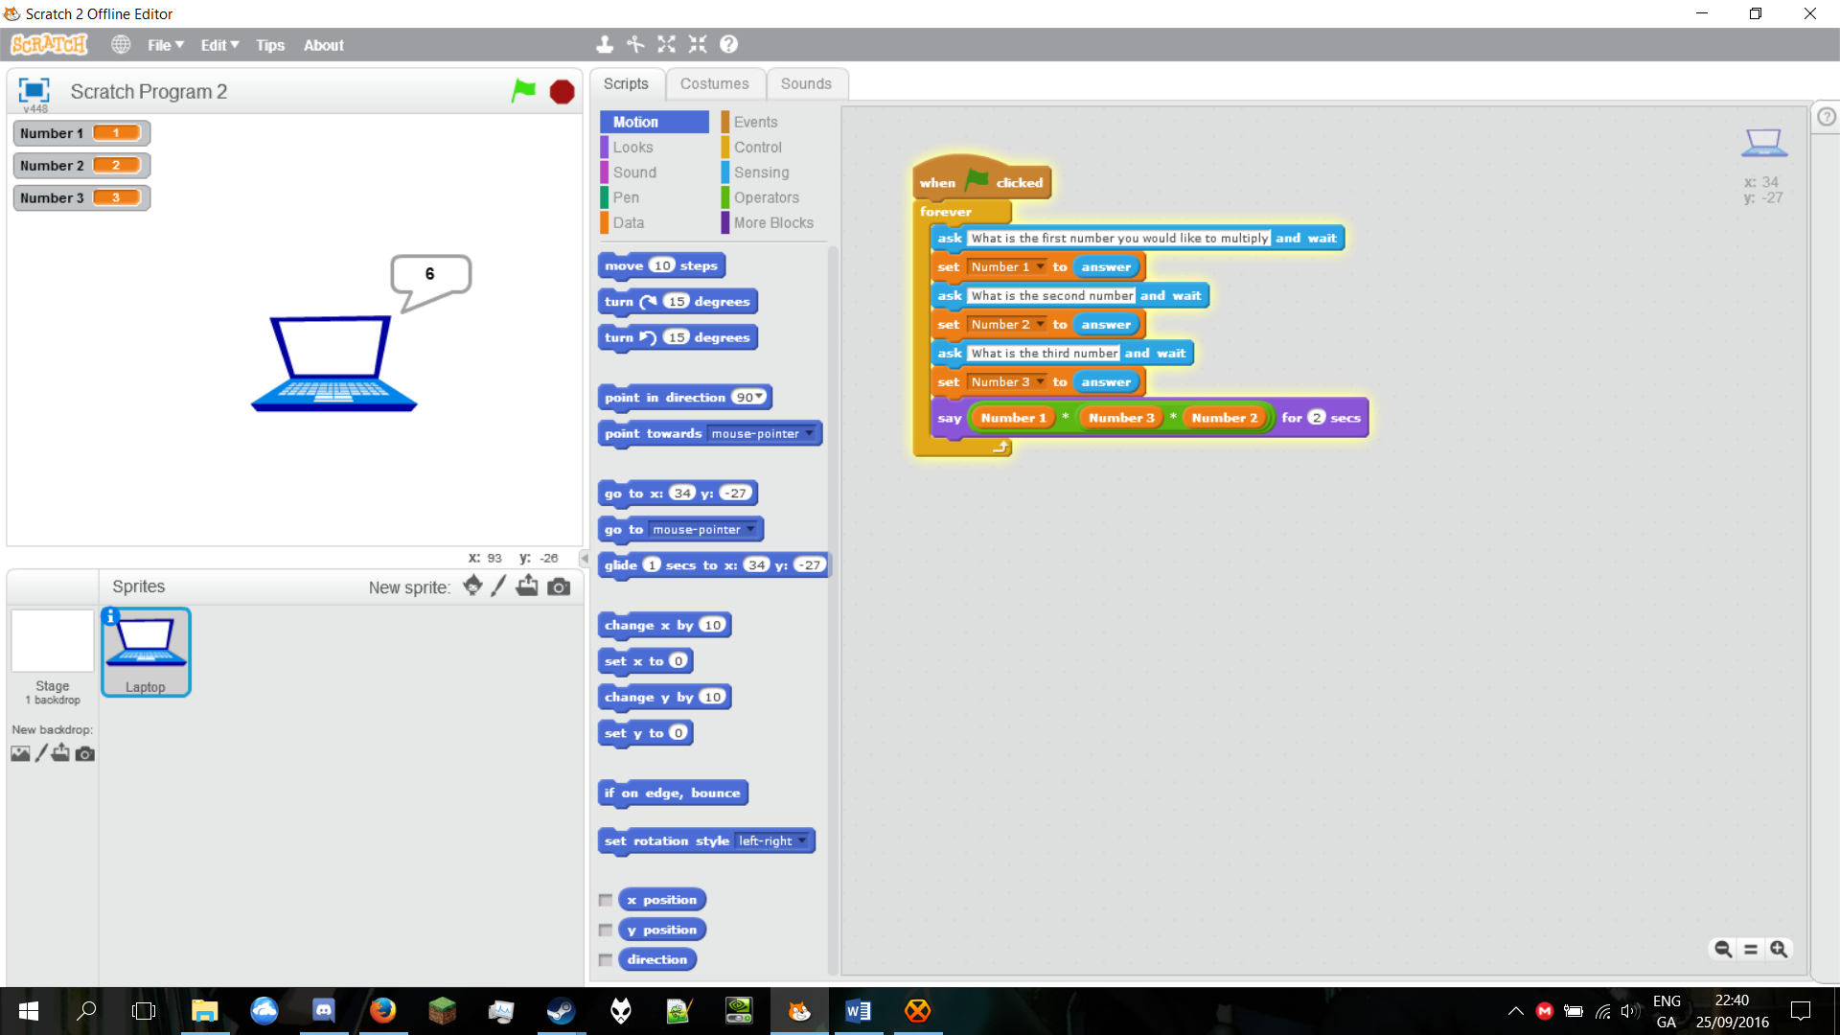

Problem 3  
Problem: Drawing a house

Objective to create a program to draw the house for me

1. When program activated
2. Set pen coordinates to 0,0
3. Rotate pen 90 degrees clockwise.
4. Move the pen forward 140 units
5. Repeat the first two steps for a total of 4 times to create a square.
6. Rotate anti clockwise to form the slope of the roof.
7. Move the pen forward a 100 units
8. Turn the pen 90 degrees and move forward another 100 units

